1. import java.util.*;
class Sports{

String getName(){
return "Generic Sports";
}

void getNumberOfTeamMembers(){
System.out.println( "Each team has n players in " + getName() );
}
}

class Soccer extends Sports{
@Override
String getName(){
return "Soccer Class";
}

void getNumberOfTeamMembers() {
System.out.println("Each team has 11 players in " + getName());
}

}

public class Solution{

public static void main(String []args){
Sports c1 = new Sports();
Soccer c2 = new Soccer();
System.out.println(c1.getName());
c1.getNumberOfTeamMembers();
System.out.println(c2.getName());
c2.getNumberOfTeamMembers();
}
}

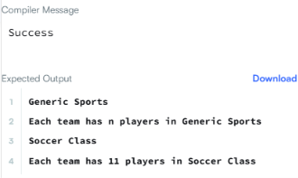
2. import java.util.*;
import java.io.*;

class BiCycle{
String define_me(){
return "a vehicle with pedals.";
}
}

class MotorCycle extends BiCycle{
String define_me(){
return "a cycle with an engine.";
}

MotorCycle(){
System.out.println("Hello I am a motorcycle, I am "+ define_me());

String temp = super.define_me();

System.out.println("My ancestor is a cycle who is "+ temp );
}

}
class Solution{
public static void main(String []args){
MotorCycle M=new MotorCycle();
}
}

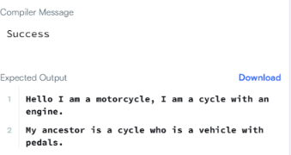
3. import java.io.*;
import java.util.*;
import java.text.*;
import java.math.*;
import java.util.regex.*;
import java.lang.reflect.*;
class Singleton {
// 1. Static reference to the single instance of the class
private static Singleton instance;

// 2. Public String instance variable
public String str;

// 3. Private constructor to prevent direct instantiation
private Singleton() {
}

// 4. Static method to return the single instance
public static Singleton getSingleInstance() {
if (instance == null) {
instance = new Singleton();
}
return instance;
}
}

public class Main {

public static void main(String args[])throws Exception{

Scanner sc=new Scanner(System.in);
Singleton s1 = Singleton.getSingleInstance(); //retrive the single instance
Singleton s2=Singleton.getSingleInstance();
assert(s1==s2);

//verify that the constructor is private
Class c=s1.getClass();
Constructor[] allConstructors = c.getDeclaredConstructors();
assert allConstructors.length==1;
for (Constructor ctor : allConstructors)
{
if(ctor.getModifiers()!=2 || !ctor.toString().equals("private Singleton()")) //The constructor must be private
{
System.out.println("Wrong class!");
}
}
String str=sc.nextLine();
s1.str=str;
s2.str=str;
System.out.println("Hello I am a singleton! Let me say "+str+" to you");

}

}
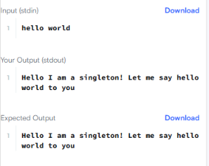
4import java.util.ArrayList;
import java.io.*;
import java.util.*;
import java.text.*;
import java.math.*;
import java.util.regex.*;

enum Color {
RED, GREEN
}

abstract class Tree {

private int value;
private Color color;
private int depth;

public Tree(int value, Color color, int depth) {
this.value = value;
this.color = color;
this.depth = depth;
}

public int getValue() {
return value;
}

public Color getColor() {
return color;
}

public int getDepth() {
return depth;
}

public abstract void accept(TreeVis visitor);
}

class TreeNode extends Tree {

private ArrayList<Tree> children = new ArrayList<>();

public TreeNode(int value, Color color, int depth) {
super(value, color, depth);
}

public void accept(TreeVis visitor) {
visitor.visitNode(this);

for (Tree child : children) {
child.accept(visitor);
}
}

public void addChildrenNode(Tree node) {
children.add(node);
}
}

class TreeLeaf extends Tree {

public TreeLeaf(int value, Color color, int depth) {
super(value, color, depth);
}

public void accept(TreeVis visitor) {
visitor.visitLeaf(this);
}
}

abstract class TreeVis {
public abstract int getResult();

public abstract void visitNode(TreeNode node);

public abstract void visitLeaf(TreeLeaf leaf);

}

class SumInLeavesVisitor extends TreeVis {
private int sum = 0;

public int getResult() {
return sum;
}

public void visitNode(TreeNode node) {
// Implementation for non-leaf node if needed
}

public void visitLeaf(TreeLeaf leaf) {
sum += leaf.getValue();
}
}

class ProductRedNodesVisitor extends TreeVis {
private long product = 1;
private boolean hasRedNode = false;
private final long MOD = 1_000_000_007;

public int getResult() {
return hasRedNode ? (int) product : 0;
}

public void visitNode(TreeNode node) {
if (node.getColor() == Color.RED) {
hasRedNode = true;
product = (product * node.getValue()) % MOD;
}
}

public void visitLeaf(TreeLeaf leaf) {
if (leaf.getColor() == Color.RED) {
hasRedNode = true;
product = (product * leaf.getValue()) % MOD;
}
}
}

class FancyVisitor extends TreeVis {
private int nonLeafEvenDepthSum = 0;
private int greenLeafSum = 0;

public int getResult() {
return Math.abs(nonLeafEvenDepthSum - greenLeafSum);
}

public void visitNode(TreeNode node) {
if (node.getDepth() % 2 == 0) {
nonLeafEvenDepthSum += node.getValue();
}
}

public void visitLeaf(TreeLeaf leaf) {
if (leaf.getColor() == Color.GREEN) {
greenLeafSum += leaf.getValue();
}
}
}

public class Solution {

// Helper structures to build the tree from adjacency lists
private static int[] values;
private static Color[] colors;
private static List<List<Integer>> adj;
private static boolean[] visited;

public static Tree solve() {
Scanner scanner = new Scanner(System.in);
int n = scanner.nextInt();

values = new int[n + 1];
for (int i = 1; i <= n; i++) {
values[i] = scanner.nextInt();
}

colors = new Color[n + 1];
for (int i = 1; i <= n; i++) {
colors[i] = scanner.nextInt() == 0 ? Color.RED : Color.GREEN;
}

adj = new ArrayList<>();
for (int i = 0; i <= n; i++) {
adj.add(new ArrayList<>());
}

for (int i = 0; i < n - 1; i++) {
int u = scanner.nextInt();
int v = scanner.nextInt();
adj.get(u).add(v);
adj.get(v).add(u);
}
scanner.close();

if (n == 1) {
return new TreeLeaf(values[1], colors[1], 0);
}

visited = new boolean[n + 1];
return buildTree(1, 0);
}

private static Tree buildTree(int u, int depth) {
visited[u] = true;

// Check if node u is a leaf (has no unvisited neighbors except its parent)
boolean isLeaf = true;
for (int v : adj.get(u)) {
if (!visited[v]) {
isLeaf = false;
break;
}
}

if (isLeaf) {
return new TreeLeaf(values[u], colors[u], depth);
} else {
TreeNode node = new TreeNode(values[u], colors[u], depth);
for (int v : adj.get(u)) {
if (!visited[v]) {
node.addChildrenNode(buildTree(v, depth + 1));
}
}
return node;
}
}

public static void main(String[] args) {
Tree root = solve();
SumInLeavesVisitor vis1 = new SumInLeavesVisitor();
ProductRedNodesVisitor vis2 = new ProductRedNodesVisitor();
FancyVisitor vis3 = new FancyVisitor();

root.accept(vis1);
root.accept(vis2);
root.accept(vis3);

System.out.println(vis1.getResult());
System.out.println(vis2.getResult());
System.out.println(vis3.getResult());
}
}

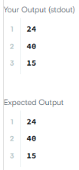
5. import java.util.*;
public class Main{

static Iterator func(ArrayList mylist){
Iterator it=mylist.iterator();
while(it.hasNext()){
Object element = it.next();
if (element instanceof String && element.equals("###"))

break;
}
return it;

}
@SuppressWarnings({ "unchecked" })
public static void main(String []args){
ArrayList mylist = new ArrayList();
Scanner sc = new Scanner(System.in);
int n = sc.nextInt();
int m = sc.nextInt();
for(int i = 0;i<n;i++){
mylist.add(sc.nextInt());
}

mylist.add("###");
for(int i=0;i<m;i++){
mylist.add(sc.next());
}

Iterator it=func(mylist);
while(it.hasNext()){
Object element = it.next();
System.out.println((String)element);
}
}
}

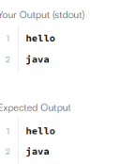
6. import java.util.*;
interface AdvancedArithmetic{
int divisor_sum(int n);
}

class MyCalculator implements AdvancedArithmetic {

@Override
public int divisor_sum(int n) {
int sum = 0;

for (int i = 1; i <= n; i++) {
if (n % i == 0) {
sum += i;
}
}

return sum;
}
}

class Solution{
public static void main(String []args){
MyCalculator my_calculator = new MyCalculator();
System.out.print("I implemented: ");
ImplementedInterfaceNames(my_calculator);
Scanner sc = new Scanner(System.in);
int n = sc.nextInt();
System.out.print(my_calculator.divisor_sum(n) + "\n");
sc.close();
}
/*
* ImplementedInterfaceNames method takes an object and prints the name of the interfaces it implemented
*/
static void ImplementedInterfaceNames(Object o){
Class[] theInterfaces = o.getClass().getInterfaces();
for (int i = 0; i < theInterfaces.length; i++){
String interfaceName = theInterfaces[i].getName();
System.out.println(interfaceName);
}
}
}

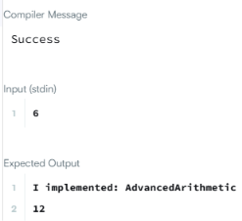
7. import java.io.*;
import java.util.*;
import java.text.*;
import java.math.*;
import java.util.regex.*;

public class Solution {

public static void main(String[] args) {
Scanner s = new Scanner(System.in);
int t = s.nextInt();
String [] pair_left = new String[t];
String [] pair_right = new String[t];

for (int i = 0; i < t; i++) {
pair_left[i] = s.next();
pair_right[i] = s.next();
}
HashSet<String> set = new HashSet<>(t * 2);
StringBuilder sb = new StringBuilder();

for (int i = 0; i < t; i++) {
set.add(pair_left[i] + " " + pair_right[i]);
sb.append(set.size()).append("\n");
}

System.out.print(sb);
}
}
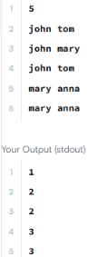
8. import java.util.*;
import java.security.*;
interface Food {
public String getType();
}
class Pizza implements Food {
public String getType() {
return "Someone ordered a Fast Food!";
}
}

class Cake implements Food {

public String getType() {
return "Someone ordered a Dessert!";
}
}
class FoodFactory {
public Food getFood(String order) {
if (order.equals("pizza")) {
return new Pizza();
} else {
return new Cake();
}

}//End of getFood method

}//End of factory class

public class Solution {

public static void main(String args[]){
Do_Not_Terminate.forbidExit();

try{

Scanner sc=new Scanner(System.in);
//creating the factory
FoodFactory foodFactory = new FoodFactory();

//factory instantiates an object
Food food = foodFactory.getFood(sc.nextLine());

System.out.println("The factory returned "+food.getClass());
System.out.println(food.getType());
}
catch (Do_Not_Terminate.ExitTrappedException e) {
System.out.println("Unsuccessful Termination!!");
}
}

}
class Do_Not_Terminate {

public static class ExitTrappedException extends SecurityException {

private static final long serialVersionUID = 1L;
}

public static void forbidExit() {
final SecurityManager securityManager = new SecurityManager() {
@Override
public void checkPermission(Permission permission) {
if (permission.getName().contains("exitVM")) {
throw new ExitTrappedException();
}
}
};
System.setSecurityManager(securityManager);
}
}
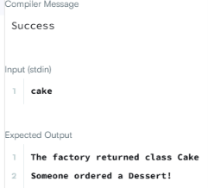
9. import java.util.Scanner;
class MyCalculator {

/*
* Create the method long power(int, int) here.
*/

public long power(int n, int p) throws Exception {

if (n < 0 || p < 0) {
throw new Exception("n or p should not be negative.");
}

if (n == 0 && p == 0) {
throw new Exception("n and p should not be zero.");
}

long result = 1;

for (int i = 0; i < p; i++) {
result *= n;
}

return result;
}
}

public class Solution {
public static final MyCalculator my_calculator = new MyCalculator();
public static final Scanner in = new Scanner(System.in);

public static void main(String[] args) {
while (in .hasNextInt()) {
int n = in .nextInt();
int p = in .nextInt();

try {
System.out.println(my_calculator.power(n, p));
} catch (Exception e) {
System.out.println(e);
}
}
}
}
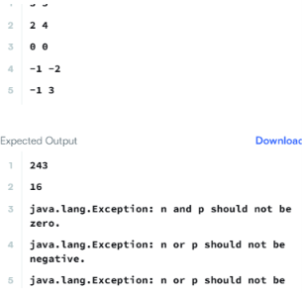
10. import java.util.*;

public class Solution {

public static void main(String[] args) {

Scanner sc = new Scanner(System.in);

try {
int a = sc.nextInt();
int b = sc.nextInt();

System.out.println(a / b);
}
catch (InputMismatchException e) {
System.out.println(e.getClass().getName());
}
catch (ArithmeticException e) {
System.out.println(e);
}

sc.close();
}
}
